Name ___________________
ACTIVITY 6-4 SH
HOW TO PRINT A TEN CARD
Note the type of information that is recorded when taking a ten card.
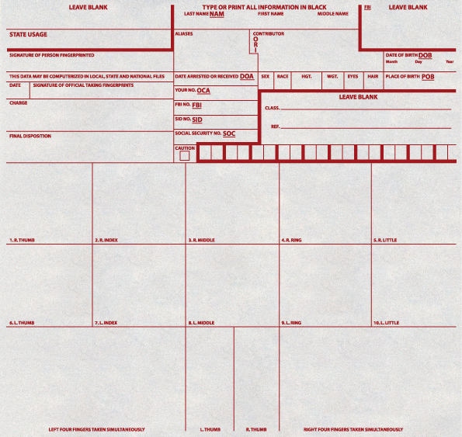
DOB: Date of birth POB: Place of birth



Instructions:
1. Cut out the ten card (top form) along the dotted lines.
2. Cut out the “four-fingers” fingerprint form (bottom form).
3. Remember to align the cards on the edge of the desk when taking your fingerprints!
4. Using a magnifying glass, examine all of your fingerprints, and label each as a loop, whorl, or arch.

